**3D PRINTER MATERIAL PREDICTION USING IBM WASTON STUDIO**

A MINI PROJECT REPORT

Submitted to

**JAWAHARLAL NEHRU TECHNOLOGICAL UNIVERSITY,**

**HYDERABAD**

In partial fulfillment of the requirements for the award of the degree of

**BACHELOR OF TECHNOLOGY**

**IN**

**COMPUTER SCIENCE AND ENGINEERING**

Submitted by

|  |  |
| --- | --- |
| **POLU RAVI CHANDRA** | **18UK1A0544** |
| **AMBATI AKSHAYA** | **18UK1A0563** |
| **JADALA KARTHIK** | **18UK1A0526** |
| **BOURISHETTY SAHITHI** | **18UK1A0504** |
|  |  |

Under the esteemed guidance of

# DR. R. VARUN REDDY

**(**Assistant Professor)



**DEPARTMENT OF COMPUTER SCIENCE AND ENGINEERING**

**VAAGDEVI ENGINEERINGCOLLEGE**

(Affiliated to JNTU Hyderabad & Approved by AICTE,

New Delhi) Bollikunta, Warangal – 506005

### 2018 – 2022

**DEPARTMENT OF COMPUTER SCIENCE AND ENGINEERING**

# VAAGDEVI ENGINEERING COLLEGE

(Affiliated to JNTU Hyderabad & Approved by

AICTE, New Delhi)Bollikunta , Warangal – 506005)

**2018 – 2022**



**CERTIFICATE**

This is to certify that the Major Project Report entitled **“3D PRINTER MATERIAL PREDICTION USING IBM WASTON STUDIO”**is being submitted by ***P.RAVI CHANDRA(*H.NO:18UK1A0544), *A.AKSHAYA* (H.NO:17UK1A0563) , *J.KARTHIK* (H.NO:18UK1A0526) , *B.SAHITHI*(H.NO:18UK1A0504)** in partial fulfillment of the requirements for the award of the degree of **Bachelor of Technology** in **Computer Science and Engineering** to **Jawaharlal Nehru Technological University Hyderabad** during the academic year **2020-21**, is a record of work carried out by them under the guidance and supervision.

#### **Project Guide** **Head of the Department**

**DR.R.VARUN Dr. R .Naveen Kumar**

(Asst Professor) (Professor)

**External**

**ACKNOWLEDGEMENT**

We wish to take this opportunity to express our sincere gratitude and deep sense of respect to our beloved **Dr.P.PRASAD RAO,** Principal, Vaagdevi Engineering College for makingus available all the required assistance and for his support and inspiration to carry out this major project in the institute.

We extend our heartfelt thanks to **Dr.R.NAVEEN KUMAR**, Head of the Department of CSE, Vaagdevi Engineering College for providing us necessary infrastructure and therebygiving us freedom to carry out the major project.

We express heartfelt thanks to **Mr.Ch.Jayaprakash**, Program Manager, SmartBridge Educational Services Private Limited,for their constant supervision as well as for providing necessary information regarding the major project and for their support in completing the major project ,mini project and internship.

We express heartfelt thanks to the guide, **DR.R VARUN** Assistant professor, Department of CSE for her constant support and giving necessary guidance for completion of this major project.

Finally, we express our sincere thanks and gratitude to my family members, friends for their encouragement and outpouring their knowledge and experience throughout the thesis.

### P.RAVI CHANDRA(18UK1A0544)

**A.AKSHAYA(18UK1A0563)**

### J.KARTHIK(18UK1A0526)

**B.SAHITHI(18UK1A0504)**

## **TABLE OF CONTENTS**:-

1. INTRODUCTION 7-8
   1. MOTIVATION 7
   2. DEFINITI0ON 7-8
   3. OBJECTIVE OF PROJECT 8
   4. PURPOSE 8
2. PROBLEM STATEMENT 9
3. LITERATURE SURVEY 9-10
   1. EXISTING SYSTEM 9
   2. PROPOSED SOLUTION 10
4. EXPERIMENTAL ANALYSIS 10-13
   1. PROJECT ARCHITECTURE 11
   2. BLOCK DIAGRAM 12
   3. SOFTWARE REQUIREMENTS 12
   4. PROJECT FLOW 13
5. DESIGN 14-15
   1. USE CASE DIAGRAM 14
   2. FLOWCHART 15
6. CODE SNIPPETS 16-31
   1. MODEL.CODE 16-20
   2. HTML CODE 21-23
   3. RESULT CODE…………………………………………………………………24-26
   4. APP1.PY CODE…………………………………………………………………….27
7. CONCLUSION 28-29
8. APPLICATION 29
9. ADVANTAGES 29
10. DIS-ADVANTAGES 30
11. FUTURE SCOPE 30

#### **12.BIBILIOGRAPHY .…30**

**LIST OF FIGURES PAGE NO.**

Figure1: Project Architecture. 12

Figure2: Block diagram representing the process of ML. 13

Figure 3: Usecase diagram. 14

Figure 4: Flowchart. 15

Figure 5: ipynb code describing importing libraries and displaying few rows from dataset: 16

Figure 6: ipynb code describing describe() method. 16

Figure 7: ipynb code describing correlation among data and whether 17

there are any null values present in dataset or not.

Figure 8: ipynb code describing pairplot. 17

Figure 9: .ipynb code describing heapmap and Label encoding.

Figure 10: ipynb code describing Model Fitting. 18

Figure 11: ipynb code describing splitting of variables**.** 19

Figure 12: ipynb code describing Applying regression on dataset and finding the accuracy**.** 20

Figure 13: home page of our project. 28

Figure 14: result page of our project. 28

Figure 15: output of our project. 29

1.INTRODUCTION:-

* 1. **MOTIVATION:**

Interest in understanding and facilitating 3D digital fabrication is growing in the HCI research community. However, most of our insights about end-user interaction with fabrication are currently based on interactions of professional users, makers, and technology enthusiasts. We present a study of casual makers, users who have no prior experience with fabrication and mainly explore walk-up-and-use 3D printing services at public print centers, such as libraries, universities, and schools. We carried out 32 interviews with casual makers, print center operators, and fabrication experts to understand the motivations, workflows, and barriers in appropriating 3D printing technologies. Our results suggest that casual makers are deeply dependent on print center operators throughout the process—from bootstrapping their 3D printing workflow, to seeking help and troubleshooting, to verifying their outputs. However, print center operators are usually not trained domain experts in fabrication and cannot always address the nuanced needs of casual makers. We discuss implications for optimizing 3D design tools and interactions that can better facilitate casual makers’ workflows.

### . DEFINITION:

The 3D printing materials industry is increasing due to the rise in the demand from healthcare, automotive, and other industries, globally. The 3D printing materials market comprises several stakeholders, such as raw material suppliers, processors, end-product manufacturers, and regulatory organizations in the supply chain. The demand side of this market is characterized by the development of various industries such as aerospace & defense, healthcare, consumer goods, and automotive. Advancements in technology and diverse applications characterize the supply side. Various primary sources from both the supply and demand sides of the market were interviewed to obtain qualitative and quantitative information.

Predicting material would be more suitable for making the 3D model. In this project, the input parameters are like Layer Height (mm), Wall Thickness (mm), Infill Density (%), Infill Pattern (honeycomb, grid), Nozzle Temperature (Cº), Bed Temperature (Cº), Print Speed(mm/s), Fan Speed (%), Roughness (µm), Tension (ultimate), Strength (MPa), Elongation (%).

### OBJECTIVE OF PROJECT:

3D printing materials come in a wide array of forms. Most consumer 3D printed products are made from thermoplastics. Designers and engineers prefer creating functional prototypes from 3D printing materials that have the same or similar material properties as what’s used in creating the finished product.

Plastics are the most widely adopted 3D printed material - and it comes in filament, resin, granule, and powder forms. Most thermoplastic 3D printing materials can be used in home 3D printing technology and professional applications as well.

The objective of this project is to predict the best material to be used for building 3D models.

### PURPOSE:

### The 3D printing materials industry is increasing due to the rise in the demand from healthcare, automotive, and other industries, globally. The global 3D printing market size was valued at USD 13.78 billion in 2020 and is expected to expand at a compound annual growth rate (CAGR) of 21.0% from 2021 to 2028. ... As a result of these benefits, the demand for 3D printers is expected to trigger more in the coming years. The demand for 3D printers are staking high day by day which leads to increase in the production of 3D printers . The production requires best material for building 3D models. The Machine Learning Model is used to predict the best material for building the 3D printers.

## **2.PROBLEM STATEMENT :-**

Much of the reason for the recent upswing in 3D printing use is that it is a simple technology that can be used in applications in all kinds of fields. In its early years, 3D printing presented high entry costs. 3D printer model and materials were expensive. In recent years, with improvements and variations in the technologies of both the machines and materials used in them, costs have been coming down, making 3D printing applications more accessible and cost-effective, across industries and education. The main problem is to find which material is the best material to be used for building 3D models.

## **LITERATURE SURVEY:-**

### EXISTING SYSTEM:

### [3D printing](https://www.twi-global.com/technical-knowledge/faqs/what-is-3d-printing), also known as [additive manufacturing](https://www.twi-global.com/technical-knowledge/faqs/what-is-additive-manufacturing), is becoming popular with manufacturers. The demand is growing due to some of the [revolutionary benefits](https://www.twi-global.com/technical-knowledge/faqs/what-is-3d-printing/pros-and-cons#Prosof3DPrinting) that it can provide.3D printers are a modern technology which is new to most students and can be used to motivate them. However, if the use of a 3D printer is limited to the downloading and printing of prefabricated models, the students will learn little about computer science. 3D printing is being used in the medical sector to help save lives by printing organs for the human body such as livers, kidneys and hearts. Further advances and uses are being developed in the healthcare sector providing some of the biggest advances from using the technology.

### The demand for 3D printers are staking high day by day which leads to increase in the production of 3D printers . The production requires best material for building 3D models. The Machine Learning Model is used to predict the best material for building the 3D printers.

### PROPOSED SOLUTION

### ML is an AI technique which allows a system or machine to learn automatically in order to predict without being explicitly programmed . Indeed, ML aims to perform a task by analyzing and learning within a given data-set. Considering different operations depends on the data, ML is divided into three categories: (a) supervised, (b) unsupervised, and (c) reinforcement learning. In supervised learning, the algorithm learns from labeled training data to help prediction of outcomes, while in unsupervised learning, the algorithm discovers relationships amongst features of interest using unlabeled data. In reinforcement learning, the model can interact with the environment to learn and take the best actions which leads to greatest rewards.

### ML presents good applicability in regression, classification, and other requests related to high-dimensional data. The training is based on learning from previous computations and the datasets can be in different forms such as audio signals , text or images .

The Machine Learning Model is used to predict the best material for building the 3D printers**.** So here we are going to use the rich set of Machine Learning algorithms to predict the material.

### 4.EXPERIMENTAL ANALYSIS

### The materials used for 3D printing are as diverse as the products that result from the process. As such, 3D printing is flexible enough to allow manufacturers to determine the shape, texture and strength of a product. Best of all, these qualities can be achieved with far fewer steps than what is typically required in traditional means of production. Moreover, these products can be made with various types of 3D printing materials. Some of the 3D printer Materials used to build 3D printers are:

### ABS

Acrylonitrile Butadiene Styrene is the plastic used in Legos. It’s tough, nontoxic and retains color well. (If you’ve ever been barefoot and stepped on a Lego, you know how tough and hard to break ABS is.)

It is also easily shaped as it melts; it becomes pliable at about 220 degrees. This does require a large heater to reach that temperature. A printer with a heated print bed is usually needed, otherwise, it will stick. As noted, ABS gets soft and pliable when heated and then sets quickly.

ABS is water and chemical resistant and does produce an unpleasant smell when heated. Because of the chemicals released in the vapor, it needs good ventilation. ABS is broken down by UV radiation, losing its color and becoming brittle, so it is not suited for extended outdoor use.

It is good for making conceptual and functional models and in manufacturing such as for the production of gears or interlocking parts.

### PLA

Polylactic Acid is a polymer plastic made from biological materials such as cornstarch or sugarcane. It is similar to the material used in biodegradable plastic packaging. It melts between 180 - 200 degrees C, depending on other materials added to it for color and texture.

PLA is tough and resilient but not as heat tolerant as ABS. It begins to deform at temperatures higher than 60 degrees C. It is also not water or chemical resistant. There is a slight smell when it is heated but no toxic odors or vapors.

Because PLA is easier to print with than ABS it is usually the preferred option for low-cost 3D printers. It sticks well to a base covered in white glue or blue painter’s tape, meaning a heated print bed is not needed.

It works well for general manufacturing 3D printing and painted miniatures. The Machine Learning model which we have used predicts the best material either ABS or PLA used to build 3D printers.

### 4.1. PROJECT ARCHITECTURE:-

### 

**Figure1: Project Architecture**

### BLOCK DIAGRAM:

### 

**Figure2: Block diagram representing the process of ML**

### 4.3. SOFTWARE REQUIREMENTS:-

* + 1. Python 3.9
    2. Anaconda Environment
    3. Flask
    4. And other python libraries like NumPy, pandas, etc..,
    5. IBM WATSON STUDIO

### 

### Project Flow:-

**You will go through all the steps mentioned below to complete the project.**

* User interacts with the UI (User Interface) to enter Data
* The entered data is analysed by the model which is integrated
* Once model analyses the input the prediction is showcased on the UI

To accomplish this, we have to complete all the activities and tasks listed below

* Data Collection.
  + Collect the dataset or Create the dataset
* Data Pre-processing.
  + Import the Libraries.
  + Importing the dataset.
  + Checking for Null Values.
  + Data Visualization.
  + Taking care of Missing Data.
  + Label encoding.
  + One Hot Encoding.
  + Feature Scaling.
  + Splitting Data into Train and Test.
* Model Building
  + Training and testing the model
  + Evaluation of Model
* Application Building
  + Create an HTML file
  + Build a Python Code

## **5.DESIGN**

### USE CASE DIAGRAM

In the Unified Modeling Language (UML), a use case diagram can summarize the details of your system's users (also known as actors) and their interactions with the system. UML is the modeling toolkit that you can use to build your diagrams. Use cases are represented with a labeled oval shape. Stick figures represent actors in the process, and the actor's participation in the system is modeled with a line between the actor and use case.

### FLOWCHART

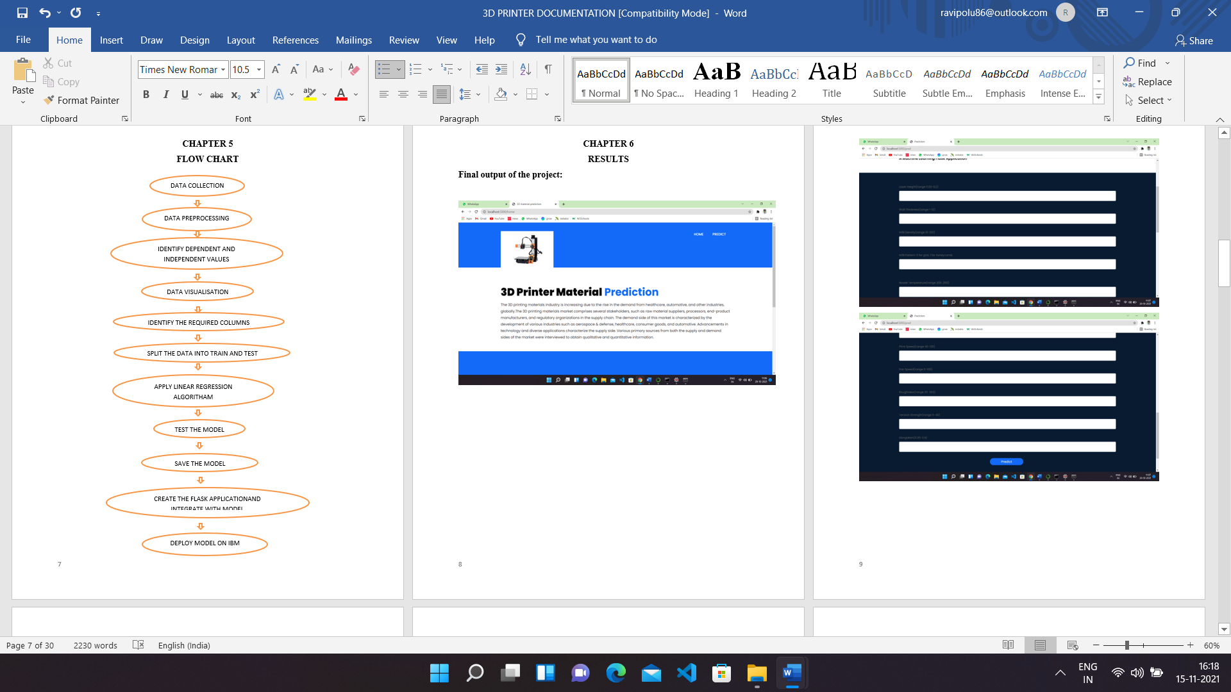

**Figure 4: Flowchart**

#### **6. CODE SNIPPETS:-**

* 1. **MODEL CODE:-**

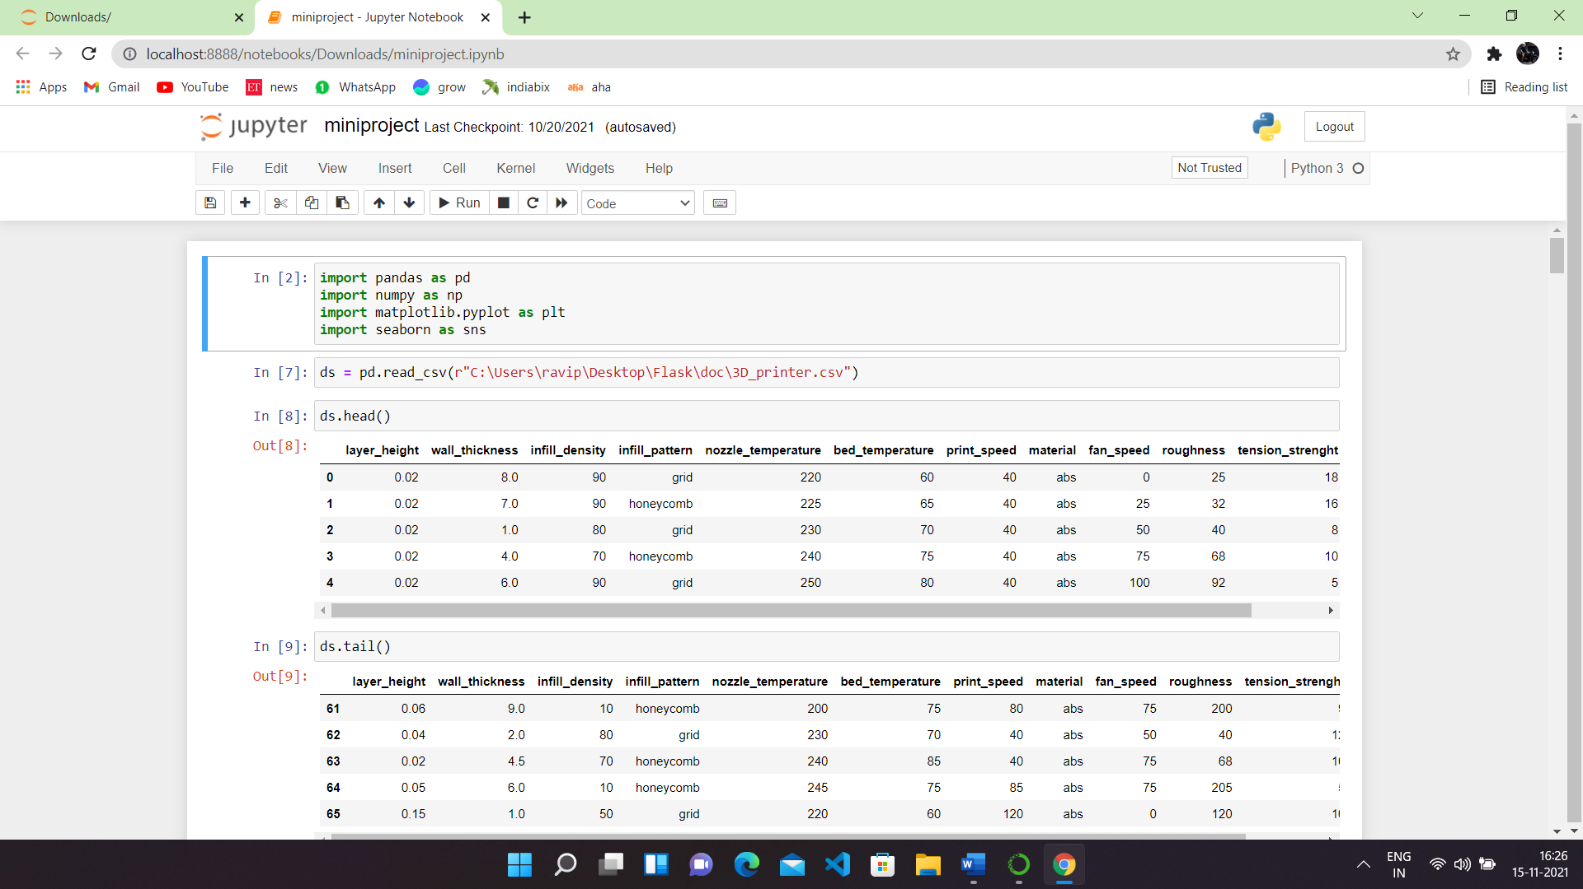

**Figure 5: .ipynb code describing importing libraries and displaying few rows from dataset:**

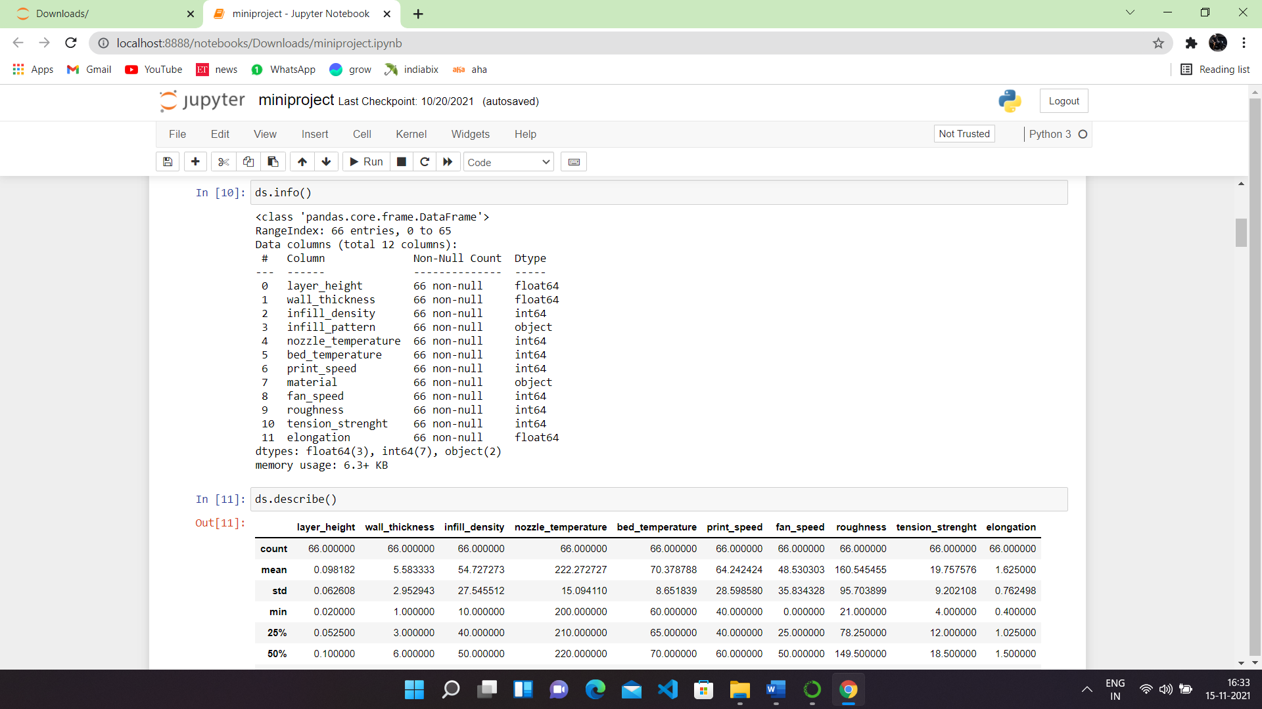

**Figure 6: .ipynb code describing describe() method.**

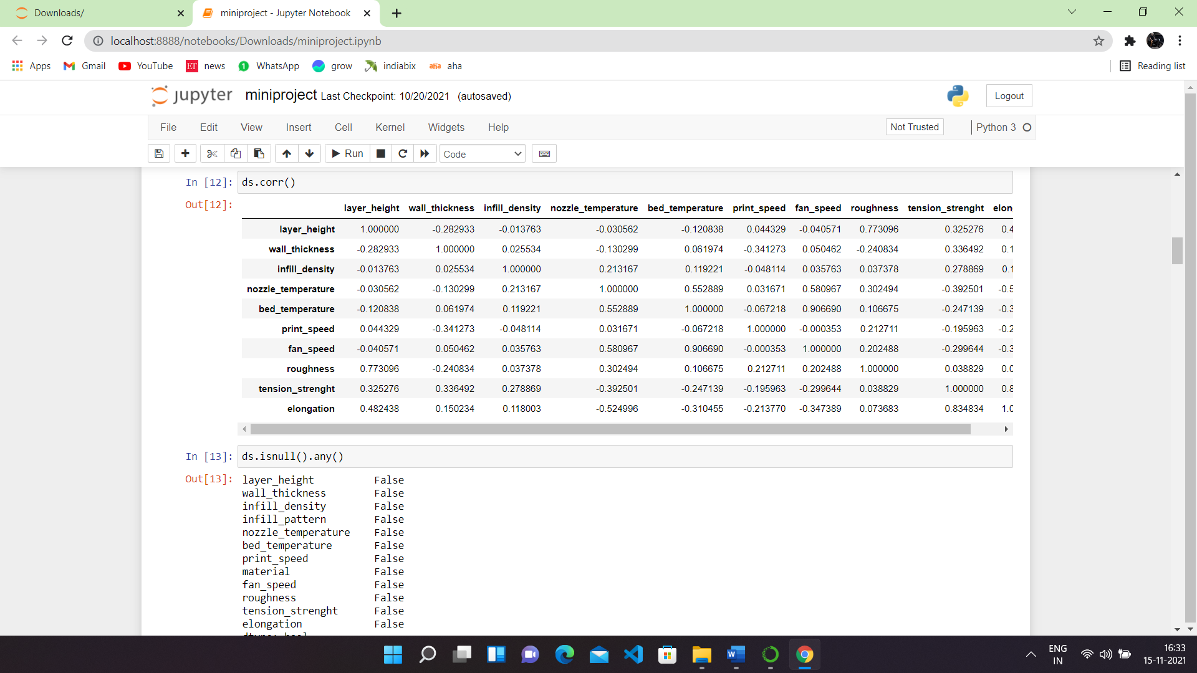

**Figure 7: .ipynb code describing correlation among data and whether there are any null values present in dataset or not.**

#### 

**Figure 8: .ipynb code describing pairplot.**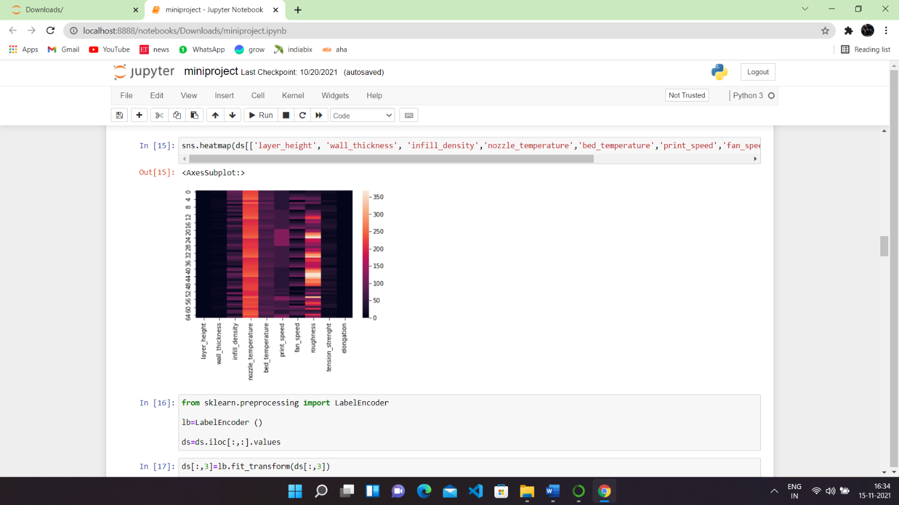

**Figure 9: .ipynb code describing heapmap and Label encoding.**

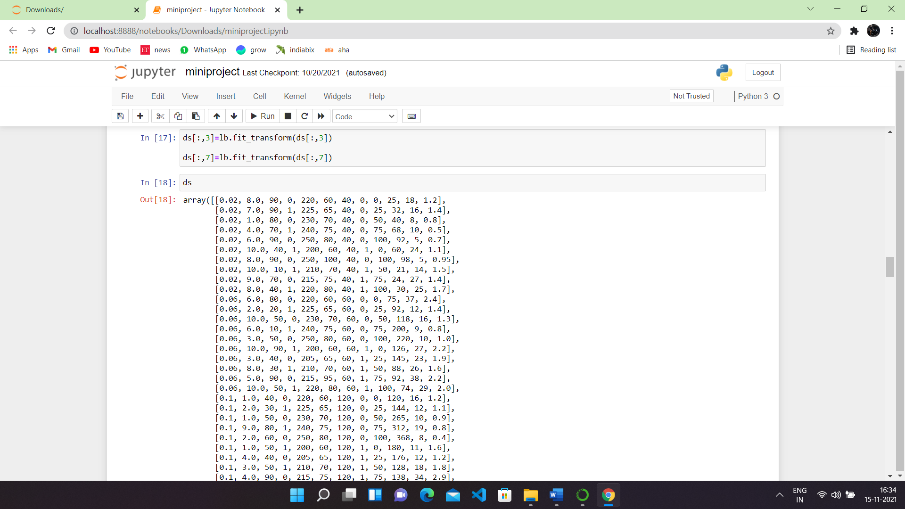

**Figure 10: .ipynb code describing Model Fitting**

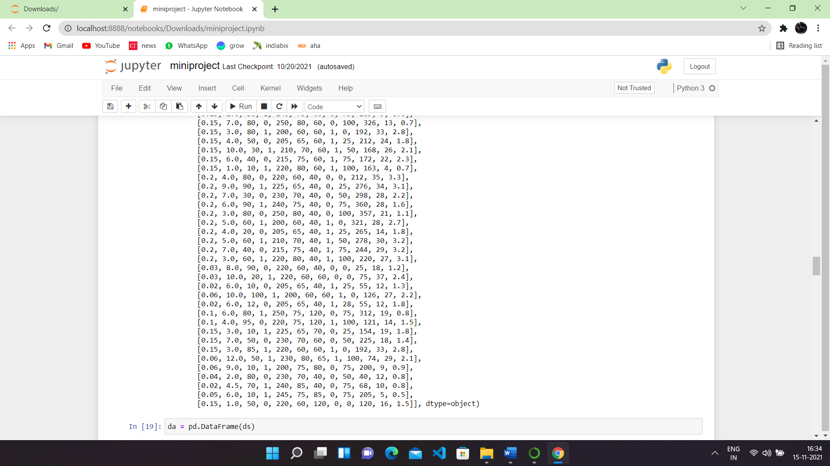

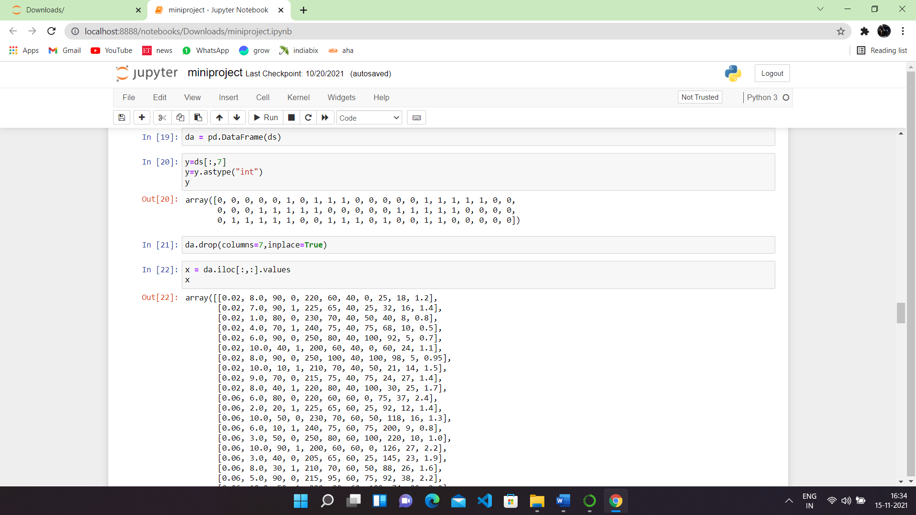

**Figure 11: .ipynb code describing splitting of variables.**

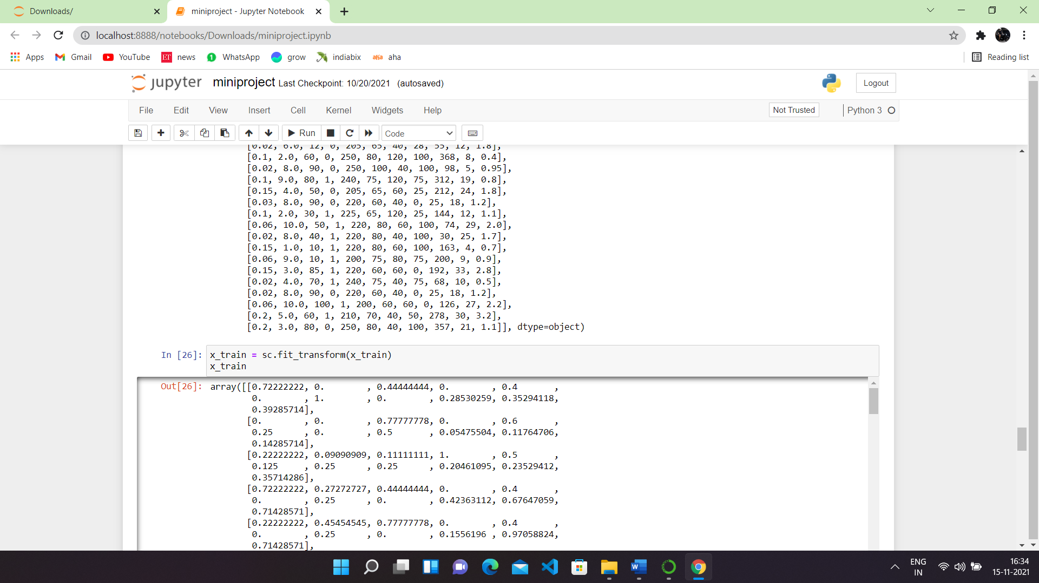

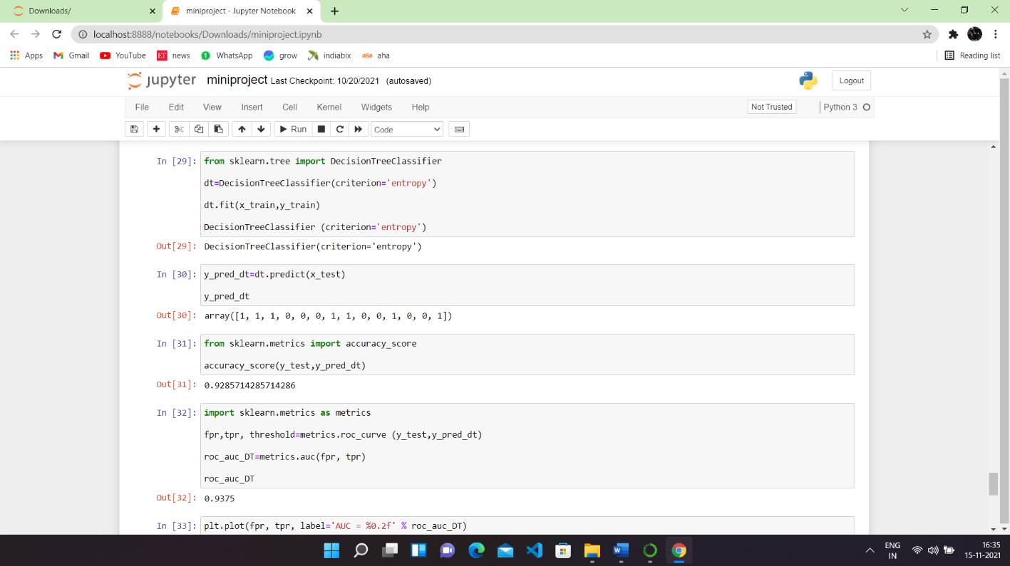

**Figure 12: .ipynb code describing Applying regression on dataset and finding the accuracy.**

**6.2 HTML CODE OF HOME**

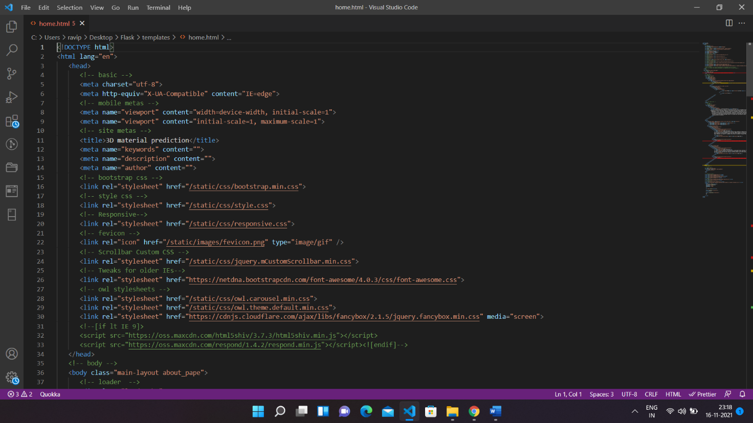

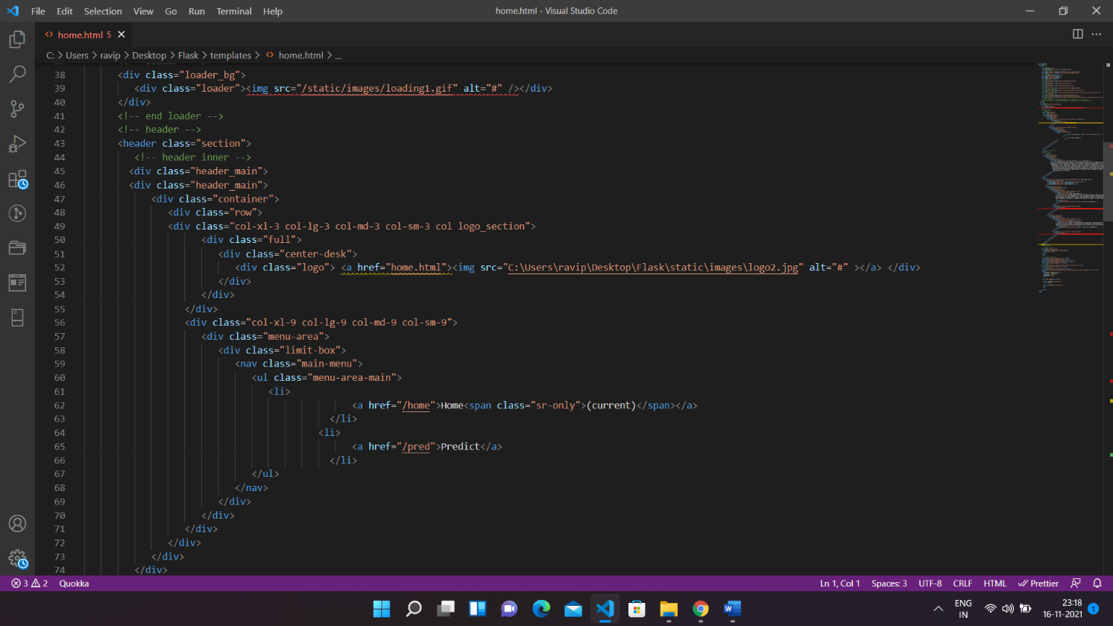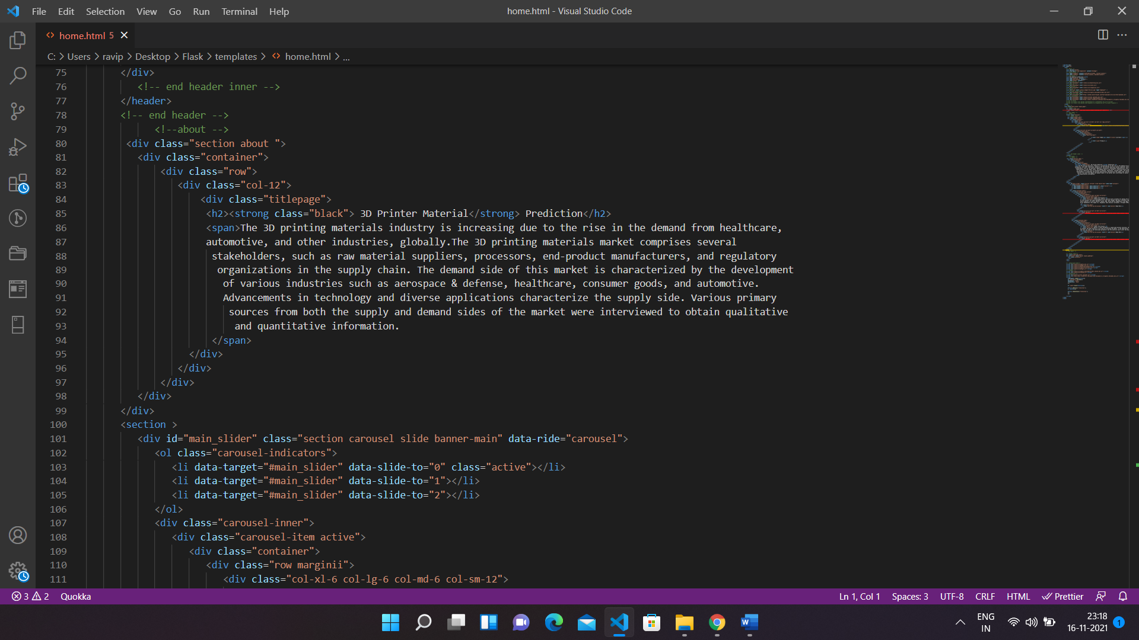

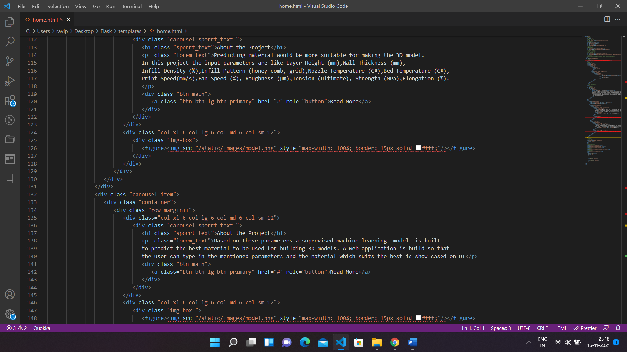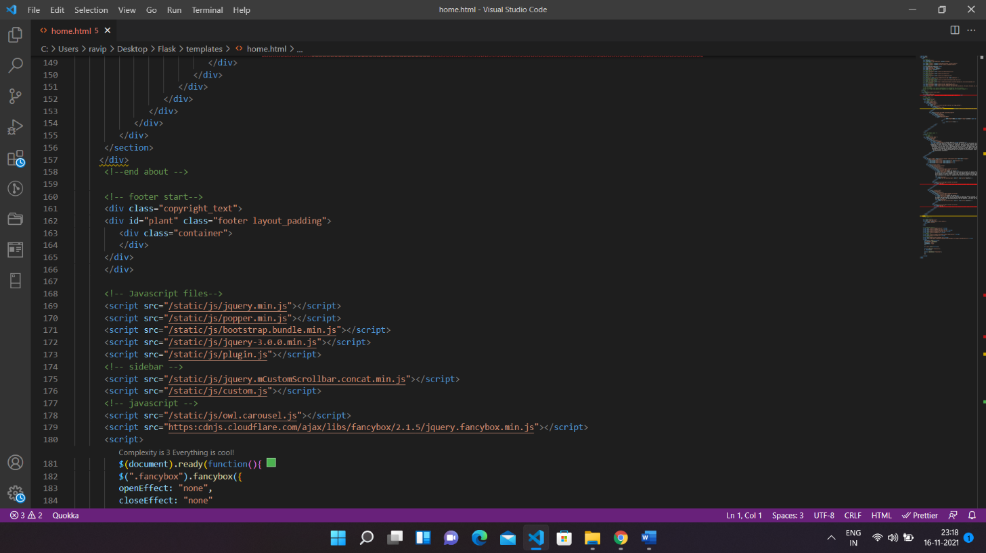

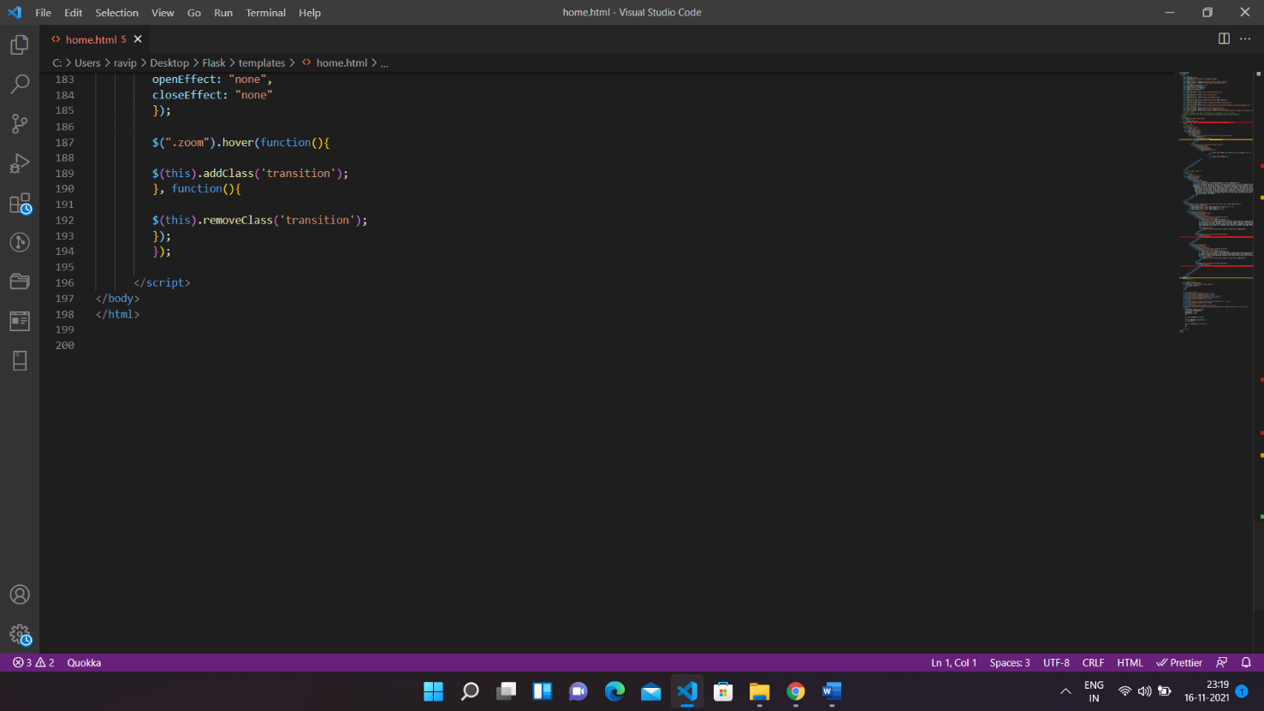

* 1. **RESULTS.HTML**

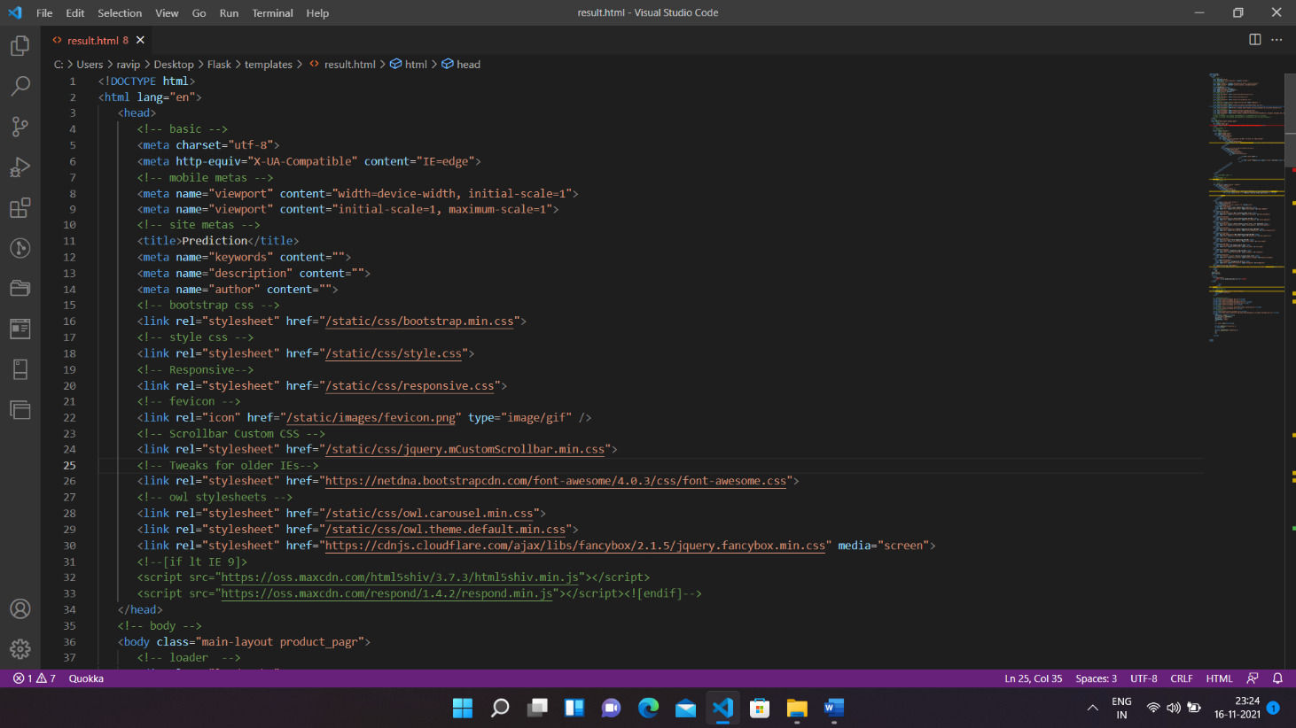

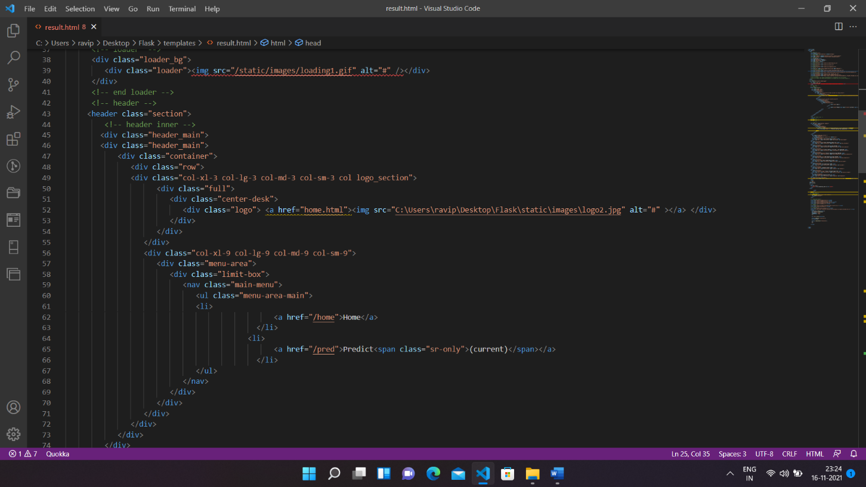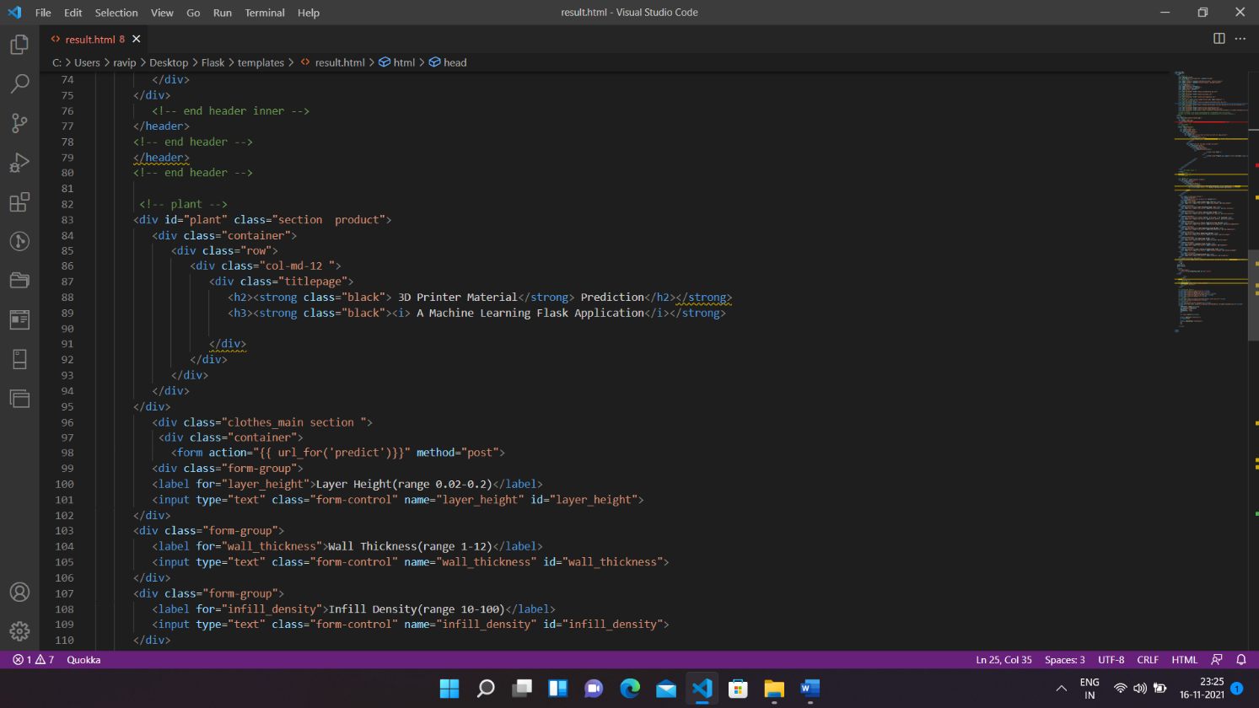

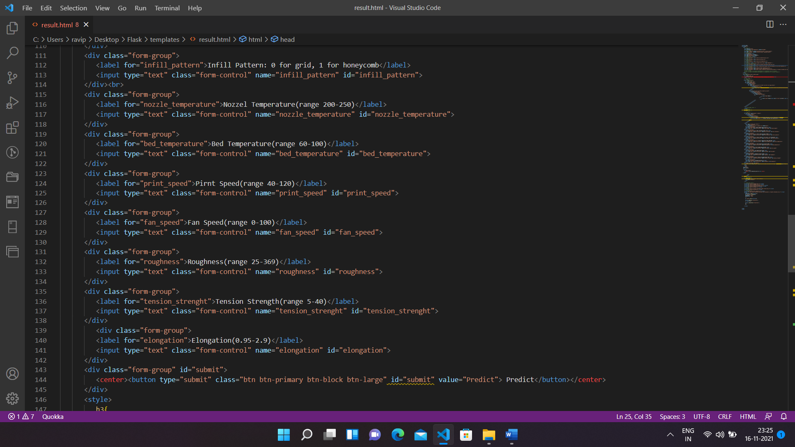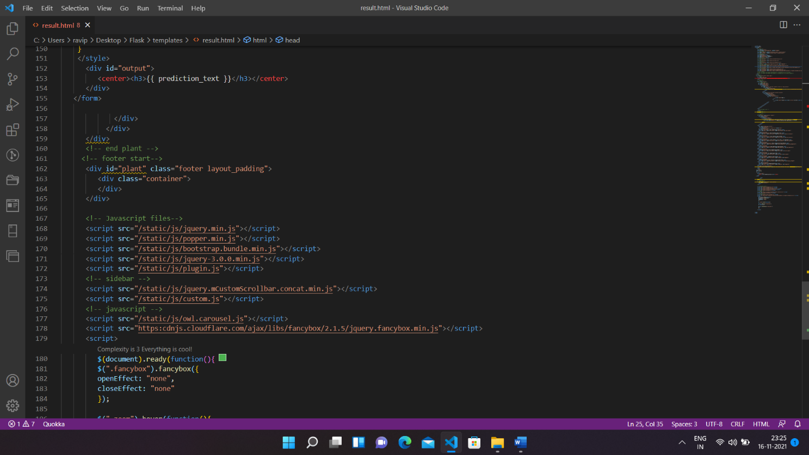

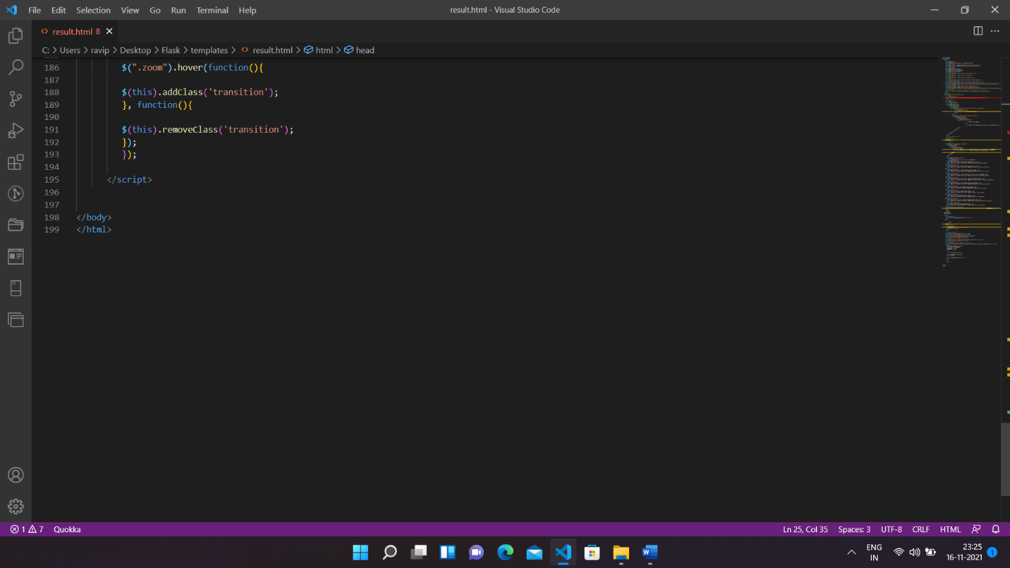

**6.4. APP.PY CODE:**

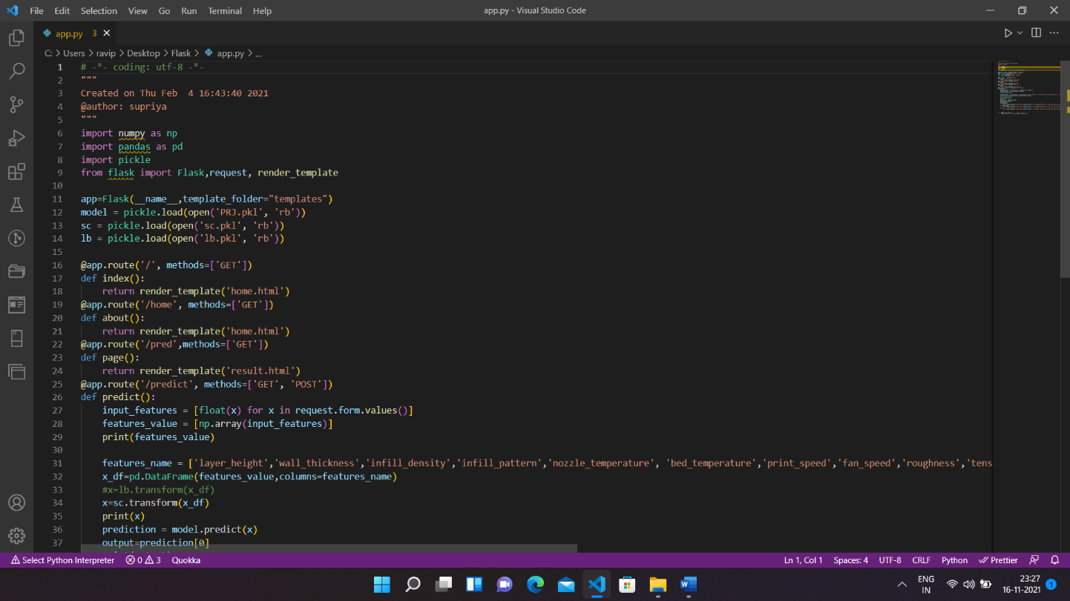

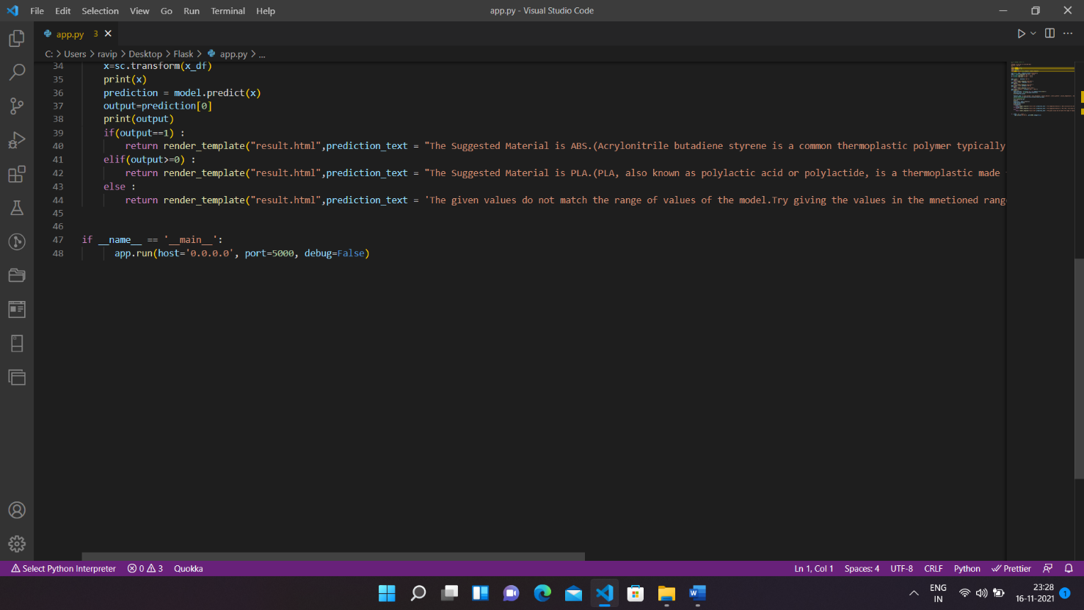

**7. CONCLUSION:-**

The following steps listed above are performed by our team, and herewith we attach snaps of our web page we achieved

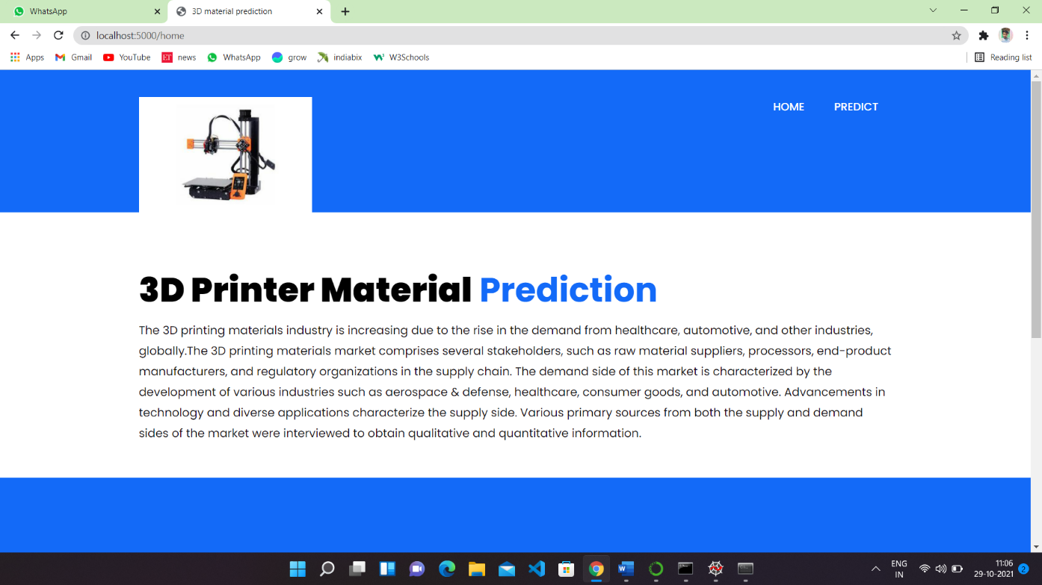

**Figure 13: home page of our project**

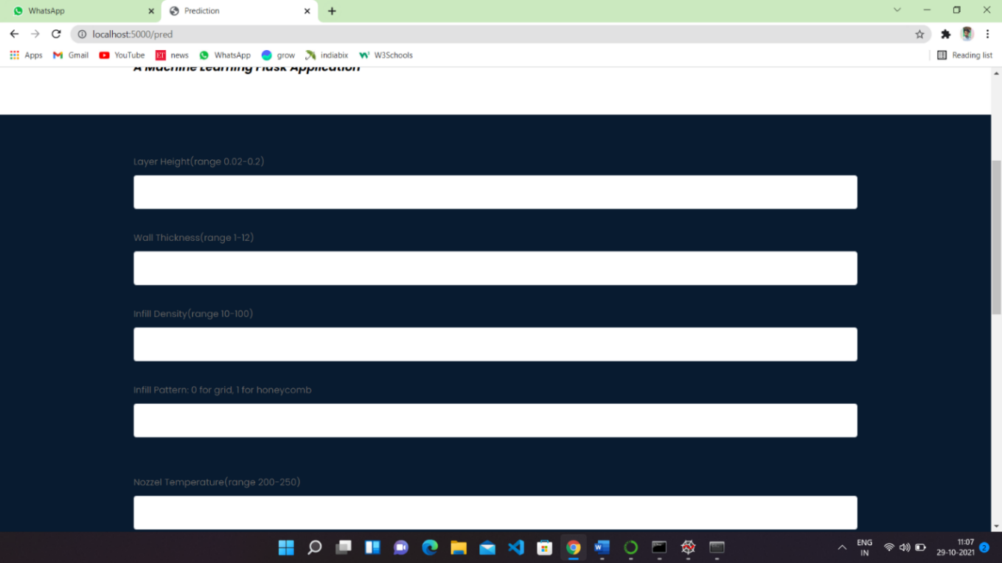

**Figure 14:result page of our project**

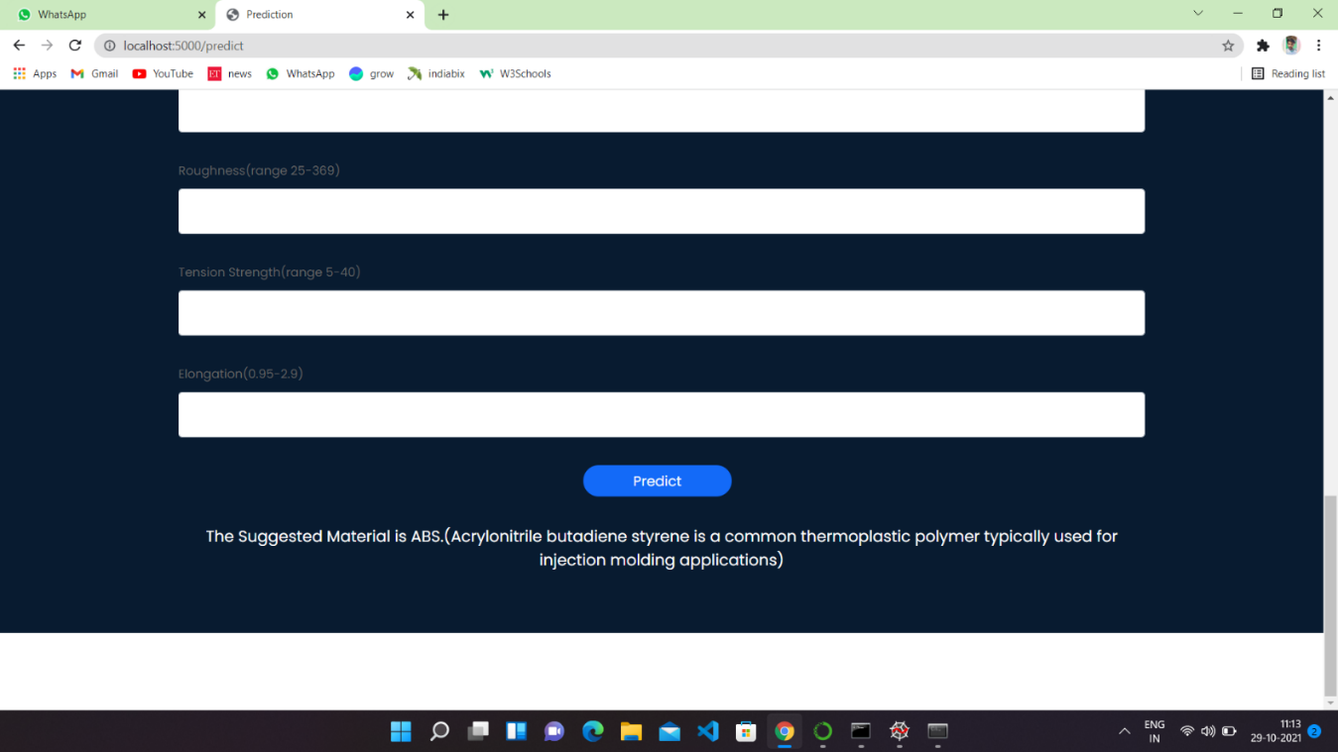

## **Figure 15:output of our project**

## **APPLICATION**

**The areas where this solution can be applied:**

* 3D Printing Industry
* Where there is an ambiguity between two materials.

# ADVANTAGES

* Lower costs - reduces maintenance due to complete report coverage and a zero-footprint environment.
* Faster results - shortens reporting time due to seamless integration and adaptive authoring.
* High performance data access across all source.
  1. **DIS-ADVANTAGES**.
* The permission level for a user cannot be modified
* Data grouping
* Custom visualizations
* Insights in visualization

## **FUTURE SCOPE:-**

**Enhancements that can be made in the future:**

* This model can be further developed to suggest material among all the possible materials based on the input parameters.
* We can scope the better job in future with easy experience.

## **BIBLIOGRAPHY:-**

References of previous works or websites visited/books referred for analysis about the project, previous solution findings

https://www.analyticsvidhya.com/blog/2017/09/common-machine-learning-algorithms